Student Guide – Answer Key

Lesson 2.07: The Purpose of Education: Unifying a Diverse Population
Name:
Date:
Bellringer: After looking at pictures of various places in Texas, describe what your daily life might be like in that place. What would you and your friends do for fun? Where would you work? Shop? Exercise? Go to school?
Location | What would life be like in this place?
Dallas, Texas  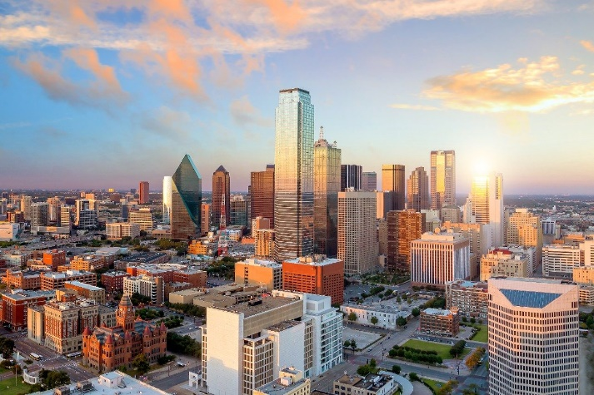 | Student responses will vary
Port Isabel, Texas  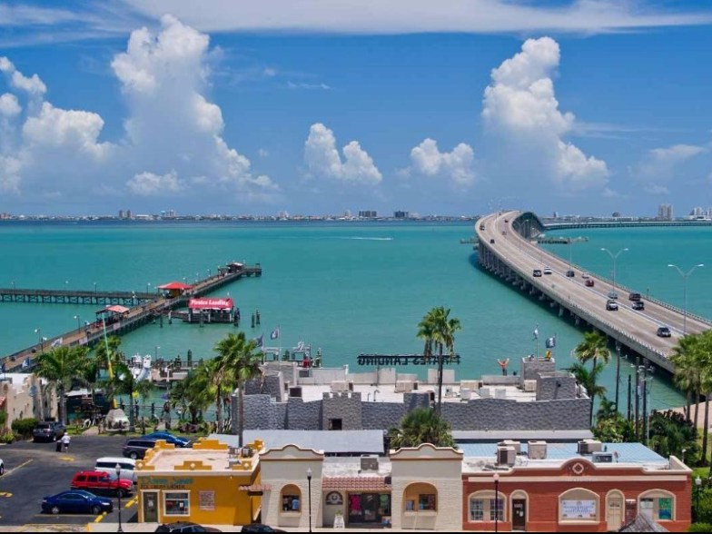 | Student responses will vary
Alpine, Texas  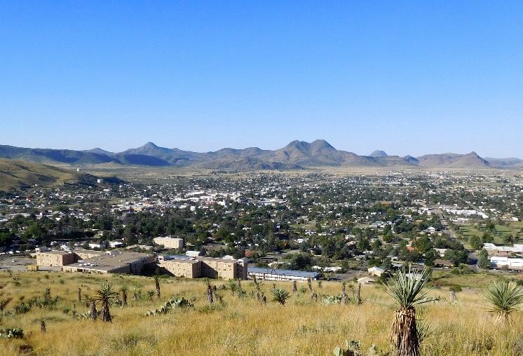 | Student responses will vary

Understanding Educational Contexts: Geography

Look at the following words. Write what these words mean to you. What thoughts come to mind when you hear each of these words?

Rural | Possible responses: Country, small town
Suburban | Possible responses: Communities, smaller than a city
Urban | Possible responses: Large city, lots of buildings, traffic, heavily populated

Urban | Suburban | Rural
A city or densely populated area. | A smaller, less densely populated area adjacent to a larger city | Area outside of a larger city with a lower population density
Characteristics:  - Land is scarce and expensive.  - Multi-tenant properties (apartments)  - Heavily developed | Characteristics:  - Subdivisions and neighborhoods  - Smaller apartment buildings  - Freestanding stores and restaurants  - Large shopping centers  - Supplier and distribution centers | Characteristics:  - More open land space  - Single family homes  - Agriculture-related businesses  - Large manufacturing enterprises  - Locally owned stores, businesses, and restaurants

Map of Texas Geographical Regions

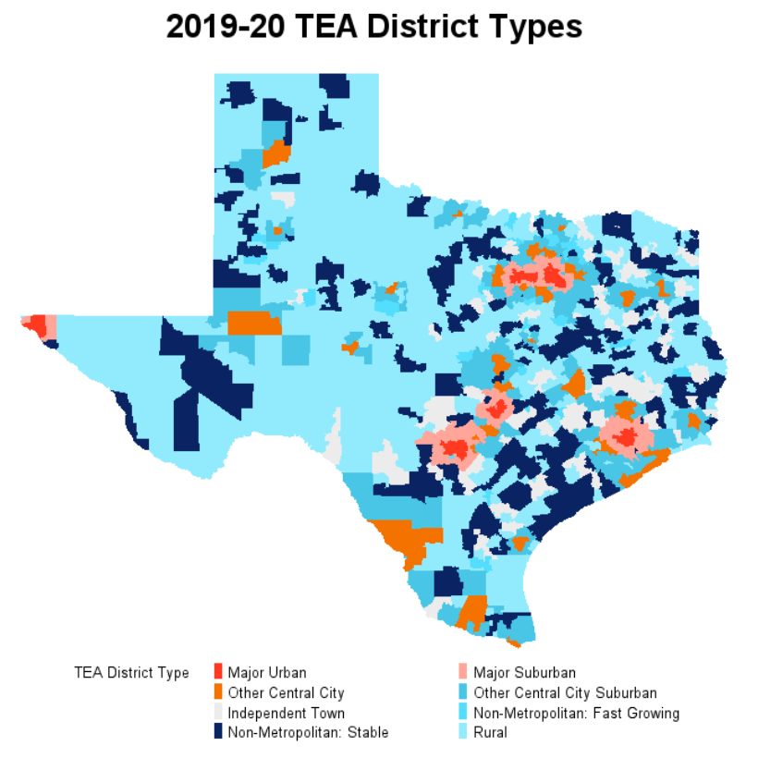

I notice | I wonder
- There are different areas across the state of Texas that are considered major urban areas with major suburban areas adjacent to them.  - There are many areas in the middle and western part of the state that are more rural. | - I wonder why most of the urban areas are in the eastern part of the state.  - I wonder how funding varies across these different areas.

Comparing Two Texas Regions/Schools
Review the chart below to compare the two different schools. Take notes on the similarities and differences you notice.
Schools | Zephyr ISD  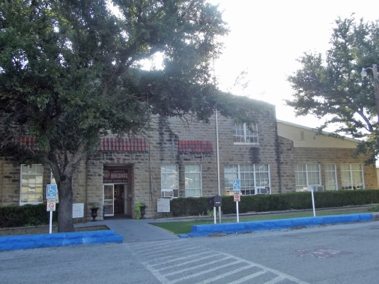 | Crespo EL  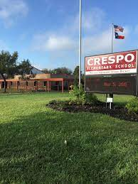
Region (urban, rural, suburban) | Rural  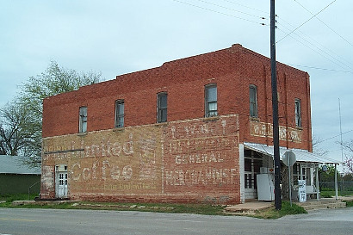 | Urban  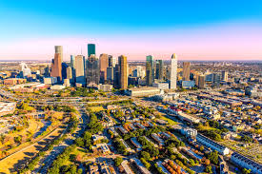
Area Population | 1,012 | 2.3 million
Median Household Income | $42,462 | $53,600
Major Industry |  | Manufacturing, aerospace & aviation, energy
School Population | 199 | 637
% Economically Disadvantaged | 59.8% | 95.4%
# of Teachers | 20.0 | 44.0
Class Size | 10 per teacher | 14.5
Amount of Funding Per Student | $6,796 | $7,659

Unifying a Diverse Population
Texas serves to unify the experience of the state’s diverse population through.
- Students - all students are expected to meet the same grade level standards. These are established by the TEKS and measured by the STAAR.
- Teachers - all teachers must complete the same certification requirements and are all help to the same standards for ethical behavior and professionalism. Places that prepare teachers are also held to state accountability standards.
- Schools – all schools are held accountable for teaching the curriculum, student achievement, and student growth.
- Curriculum – all students have access to high-quality instructional materials that have been approved through the state board.

