Student Guide – Answer Key

Lesson 6.04: Standard & Objective Alignment
Name:
Date:
Bellringer: Consider this 3rd grade standard:

The student understands the purposes of earning, spending, saving, and donating money. The student is expected to:
- Identify ways of earning, spending, saving, and donating money.

Work with a partner to underline the verbs in the student expectation and brainstorm ways in which students would show their learning of this concept.
Scenarios where students investigate earning, spending, saving, and donating money; scenarios where students must make decisions about how to use a set amount of money; create a budget plan; create business/store where students must earn, spend, save, and donate money; create a poster that explains earning, spending, saving, and donating money and tips for each.

Intro to Lesson Standards & Objectives
Write the definition and notes for each term below as they are discussed in the lesson.
Term | Definition | Notes:
Standards | The learning goals or expectations for what students should know and be able to do at each grade level. | Standards help you identify the most important content to teach for your grade level. They help you identify what students should know and be able to do by the end of the grade level. Standards also help you develop strong objectives that will guide your daily lessons.
Objectives | Brief statements that describe what students will be expected to learn by the end of the unit or lesson. | Objectives are built from the standards.  Standards are broad and used to guide curriculum through the year; whereas objectives are more narrow statements of what students will know and be able to do by the end of a lesson.

Practice #1
You are going to work in groups to examine the standards and objectives for a grade 1 science lesson plan. You will look at the standards in the lesson plan to identify the verbs and the content and use that to determine what students need to know and do. You will then analyze each objective in the lesson plan to determine which standard it aligns to.

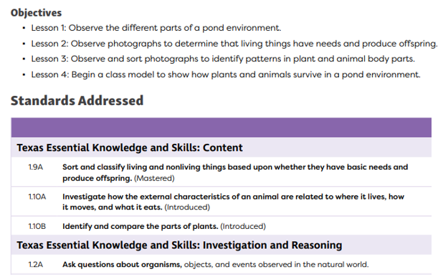

Standard | Do (verbs) | Content (nouns) | Objective that aligns to the standard
1.9A | Sort, classify | living and nonliving things based on basic needs and production of offspring. | - Observe photographs to determine that living things have needs and produce offspring
1.10A | Investigate | How external characteristics of an animal are related to where it lives, how it moves, and what it eats | - Observe different parts of a pond environment  - Observe and sort photographs to identify patterns in plant and animal body parts.  - Begin a class model to show how plants and animals survive in a pond environment
1.10B | Identify  Compare | Parts of plants | - Observe different parts of a pond environment  - Observe and sort photographs to identify patterns in plant and animal body parts.  - Begin a class model to show how plants and animals survive in a pond environment
1.2A | Ask | Questions about organisms | - Observe photographs to determine that living things have needs and produce offspring  - Observe and sort photographs to identify patterns in plant and animal body parts.

Practice #2
Review the standards (same as in practice #1) and analyze the objectives in the lesson plan to determine if they are aligned to the standards. Provide evidence to support your claim. Make suggestions for improvement.

Objectives:
- Identify living and nonliving things
- Identify the parts of a plant
- Learn about animals and their habitats
Standards Addressed:
TEKS: Content
- 1.9A - Sort and classify living and nonliving things based upon whether they have basic needs and produce offspring. (Mastered)
- 1.10A - Investigate how the external characteristics of an animal are related to where it lives, how it moves, and what it eats. (Introduced)
- 1.10B - Identify and compare the parts of plants. (Introduced)
TEKS: Investigation and Reasoning
- 1.2A - Ask questions about organisms, objects, and events observed in the natural world.

Objective | Standard | Aligned to Standards (Y, N or partially) | Evidence to support your claim
Identify living and nonliving things | 1.9A - Sort and classify living and nonliving things based upon whether they have basic needs and produce offspring. | No | The objective only has students identify living and nonliving things. It does not specify that it will be based upon whether they have basic needs and produce offspring
Identify the parts of a plant | 1.10B - Identify and compare the parts of plants. | Partially | Students only identify the parts of a plant. They do not compare the parts of the plant.
Learn about animals and their habitats | 1.10A - Investigate how the external characteristics of an animal are related to where it lives, how it moves, and what it eats.  1.2A - Ask questions about organisms, objects, and events observed in the natural world. | Partially | The objective is too broad to really know if what students will be learning is aligned to the standards. The level of rigor for the first standard asks students to investigate how the external characteristics of an animal are related to where it lives, how it moves, and what it eats. This was not made clear in the objective.

