Exit Ticket - Answer Key

Lesson 6.10: Scaffolding a Lesson | Practice
Name:
Date:
Look at the lesson objective and assessment below. Sort the practice activities into examples and nonexamples.

Lesson Objective: Students will use a number line as a strategy to tell time to the nearest minute on a clock.

Assessment: Use a number line to read and write the time on the clock to the nearnest one-minute.

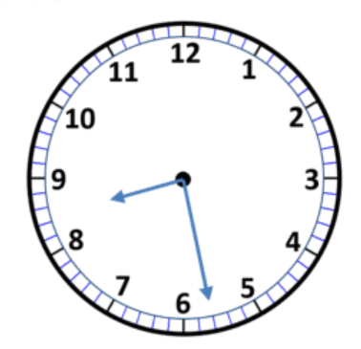

Practice Activities:
- Skip count as a class by fives
- Complete a crossword puzzle with time words
- Design your own analog clock
- Use number lines to skip count by fives and ones to tell time
- Work with a partner to tell time using a number line as a strategy
- Talk with a partner about where you use time in real life
- Watch a video about time

Examples | Nonexamples
- Skip count as a class by fives.  - Use number lines to skip count by fives and ones to tell time.  - Work with a partner to tell time using a number line as a strategy. | - Complete a crossword puzzle with time words.  - Design your own analog clock.  - Talk with a partner about where you use time in real life.  - Watch a video about time.

