Student Guide

Lesson 7.01: High Leverage Teaching Practices | Introduction
Name:
Date:

Bellringer: Read each of the following practices below used by a teacher. Based on what you know, rate each as an effective practice or not an effective practice and share your reasoning.
Teacher Practice | Is this an effective teaching practice? (Yes/No/Not Sure) | Explain your reasoning
At the beginning of a lesson, at teacher shares lesson objectives.
After delivering the lesson, the teacher provides examples and non-examples of the content the students need to learn
The teacher returns the work one week after it’s completed.
The teacher models how to complete a word problem with a clear, step by step explanation
The teacher groups students to discuss the theme of a poem they read in class.

Notes: High Leverage Practices

High Leverage Teaching Practice
Evidence based practice

Exploration: High Leverage Practices

High Leverage Practice | What is it? /Key Points | How can teachers demonstrate this practice?
- Focus on Instructional Outcomes
- Structuring Lessons
- Explicit Teaching
- Worked Examples
- Collaborative Learning
- Multiple Exposures
- Questioning
- Metacognitive Strategies
- Differentiated Instruction

The following passages about each of the high leverage practices have been excerpted from High Impact Teaching Strategies: Excellence in Teaching and Learning, State of Victoria (Department of Education and Training)- https://www.education.vic.gov.au/Documents/school/teachers/support/high-impact-teaching-strategies.pdf
- Focus on Instructional Outcomes (referred to as “Setting Goals” in the original document)
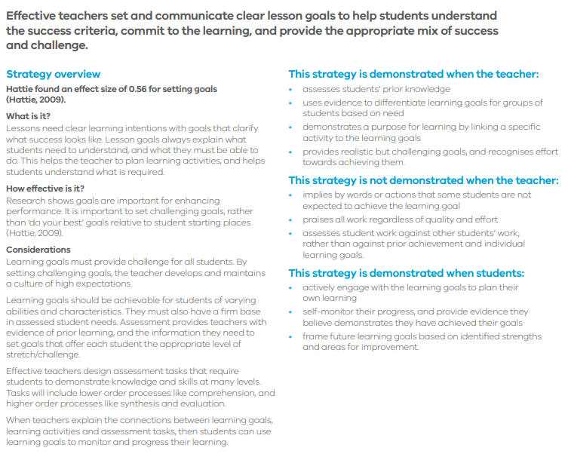

- Structuring Lessons
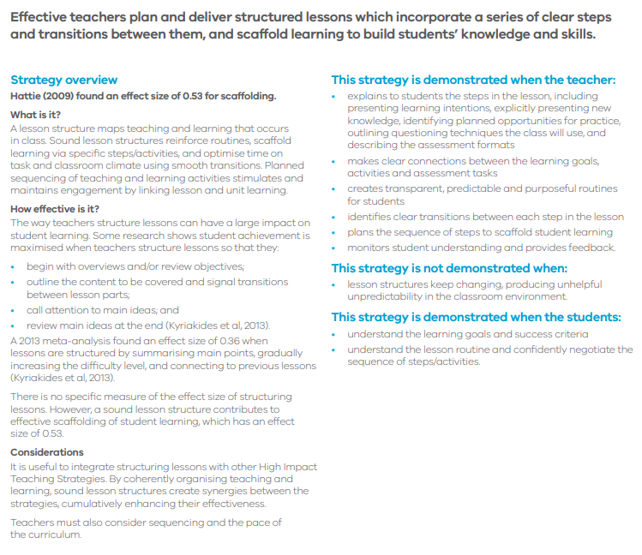

- Explicit Teaching 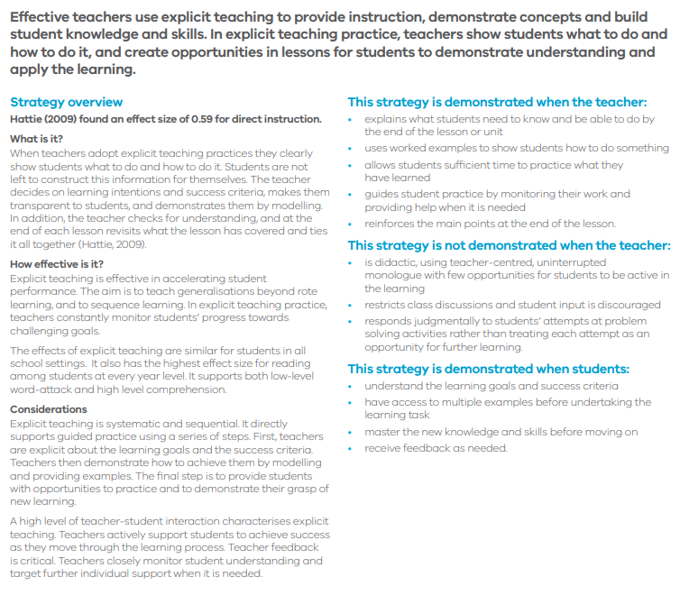

- Worked Examples
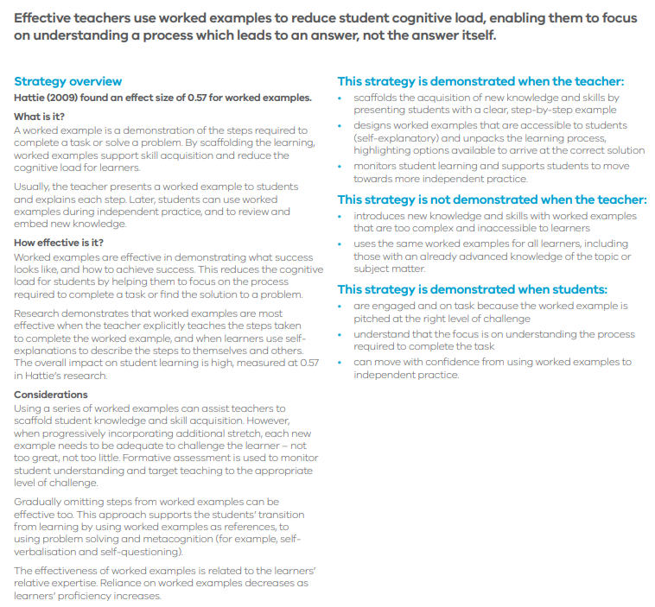

- Collaborative Learning

- Multiple Exposures
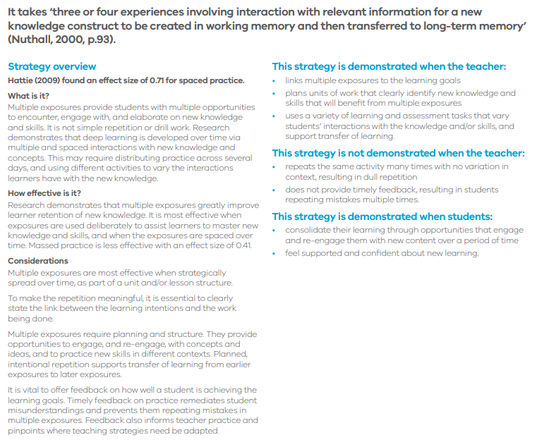

- Questioning
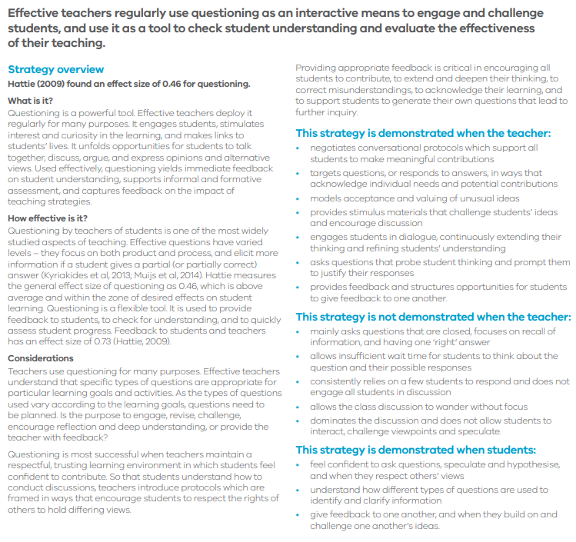

- Metacognitive Strategies
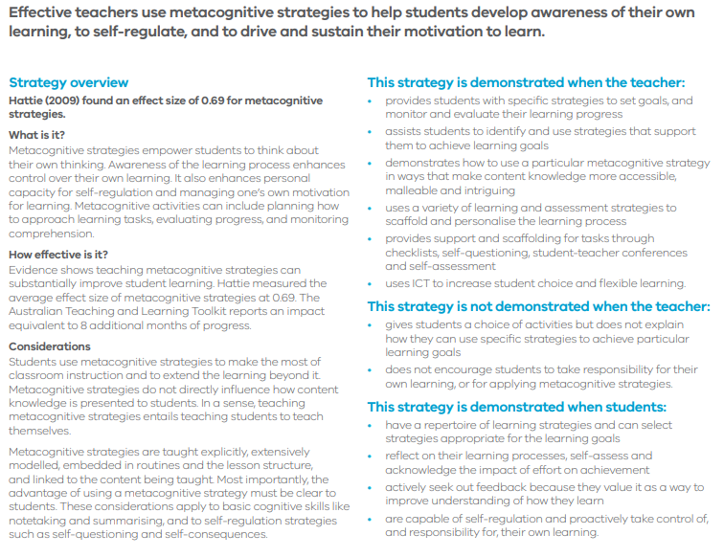

- Differentiated Instruction (Called “Differentiated Teaching” in the original document)
